Project Structure (Eclipse)

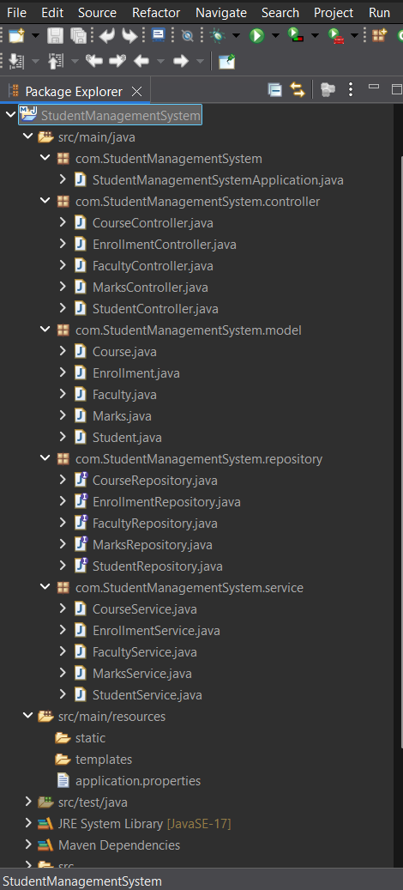

Student.java Code
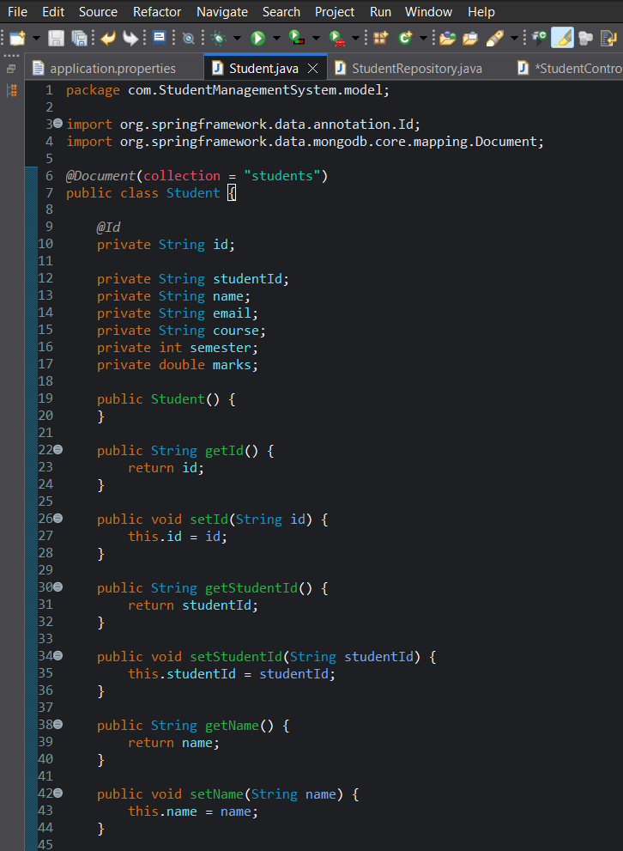
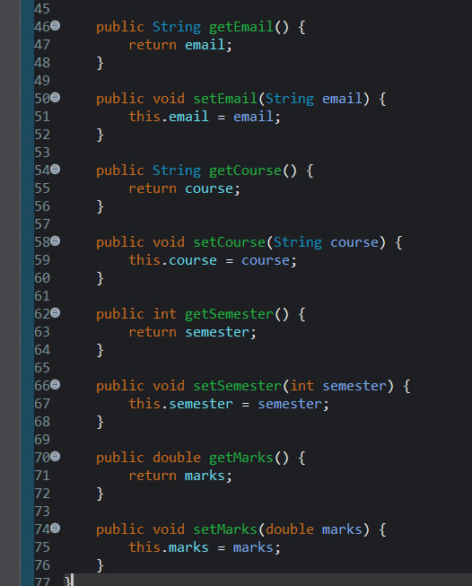

StudentRepository.java

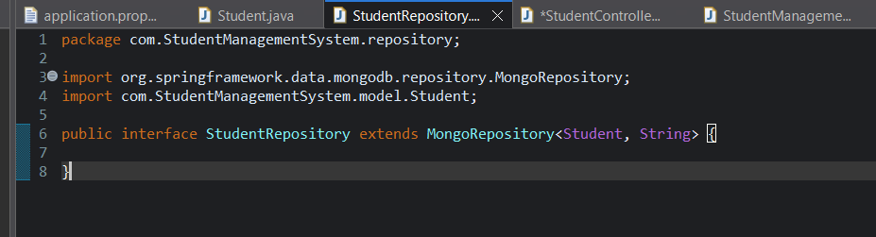

StudentController.java

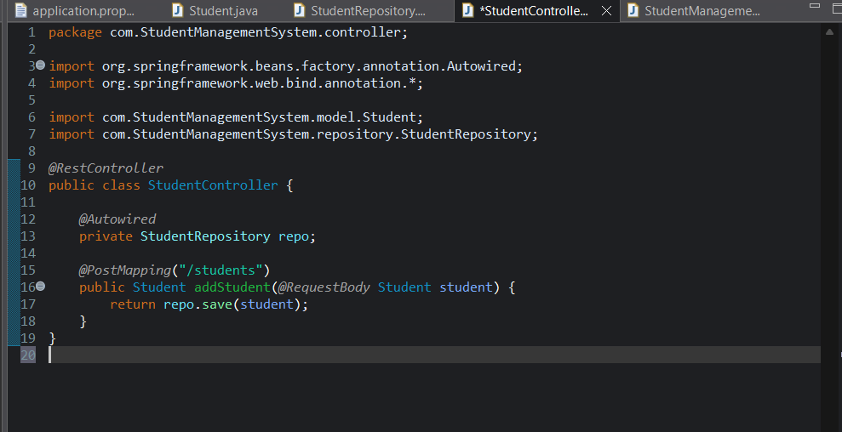

Application.properties

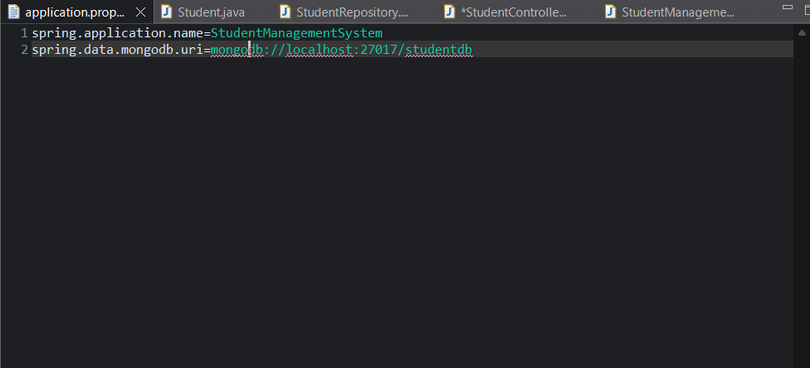

Spring Boot Running

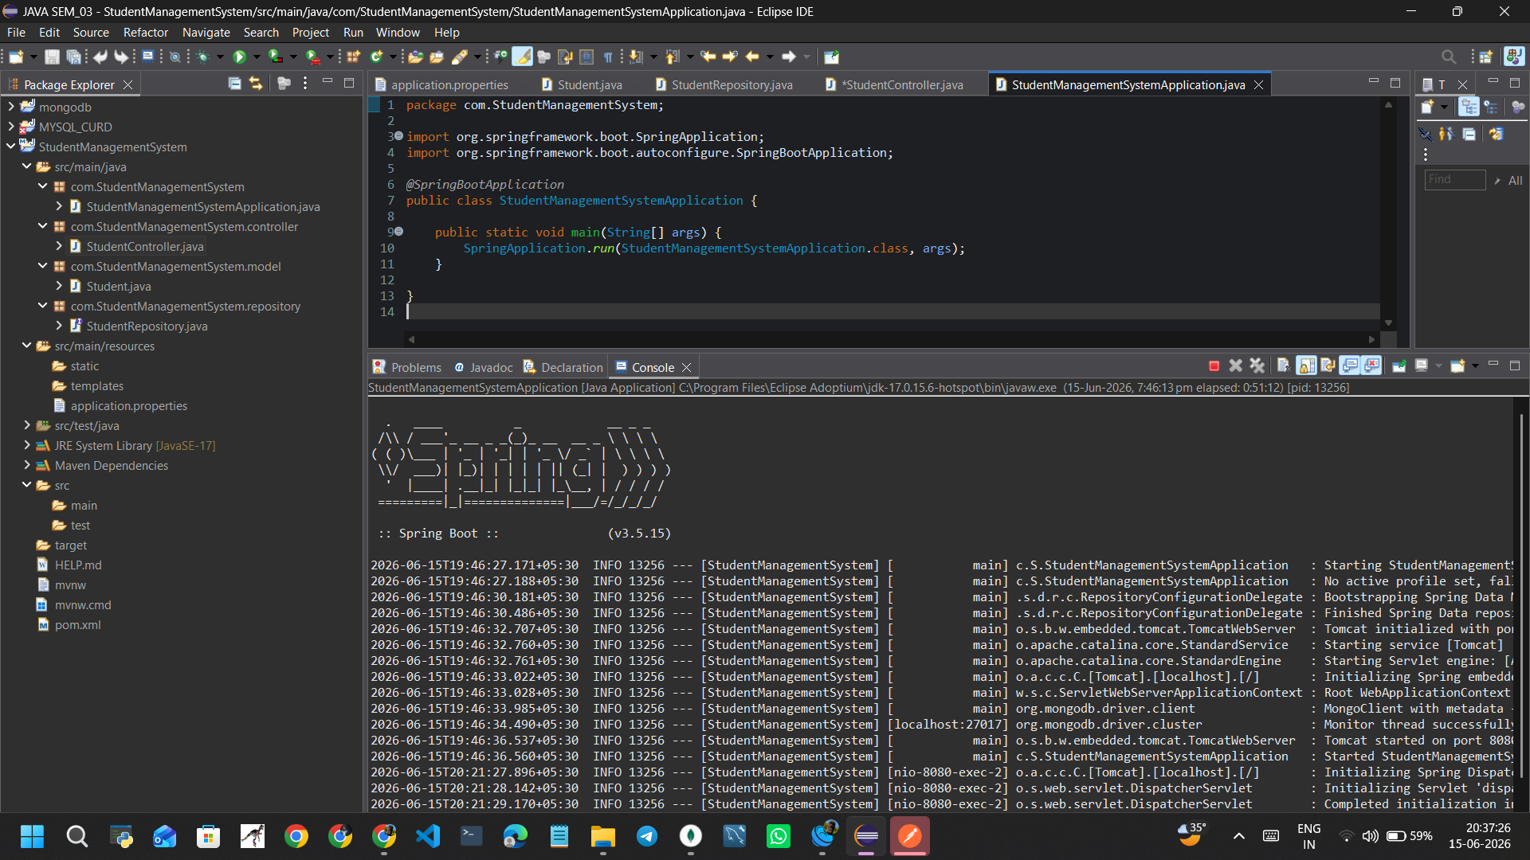

Postman Request and response
- CREATE STUDENT
Method: POST
URL:
http://localhost:8080/students
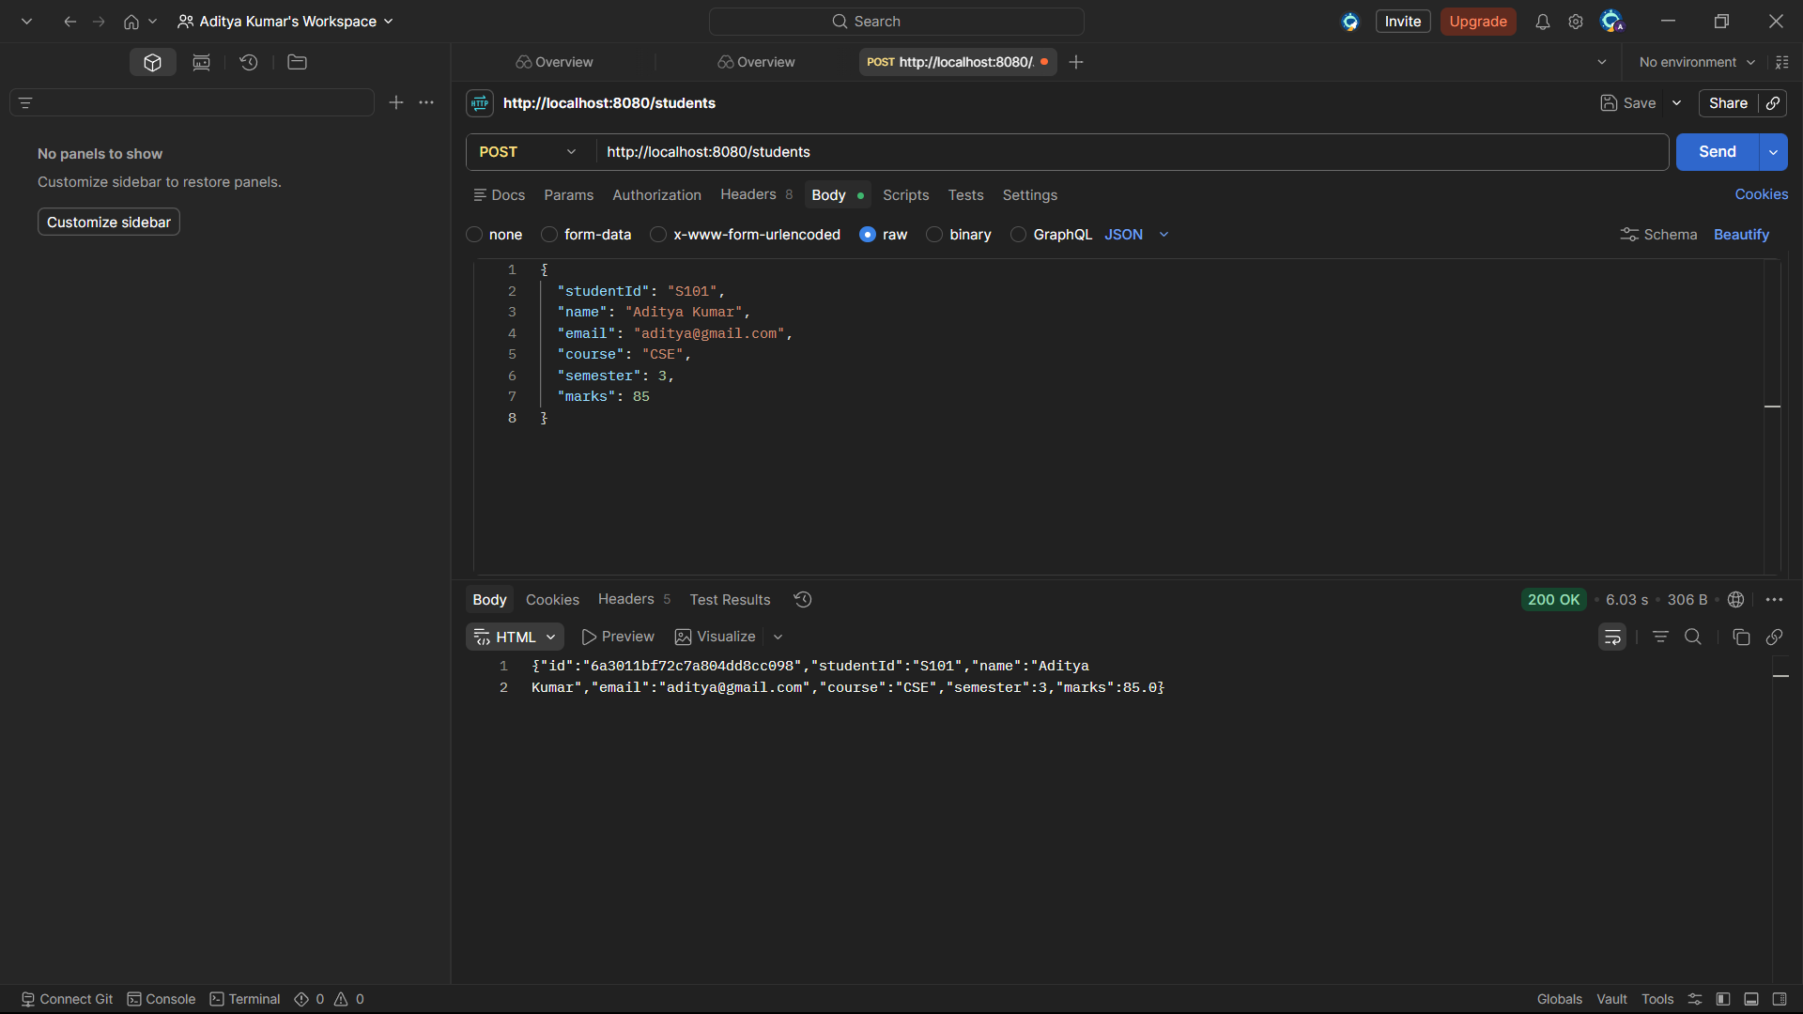

MongoDB Compass

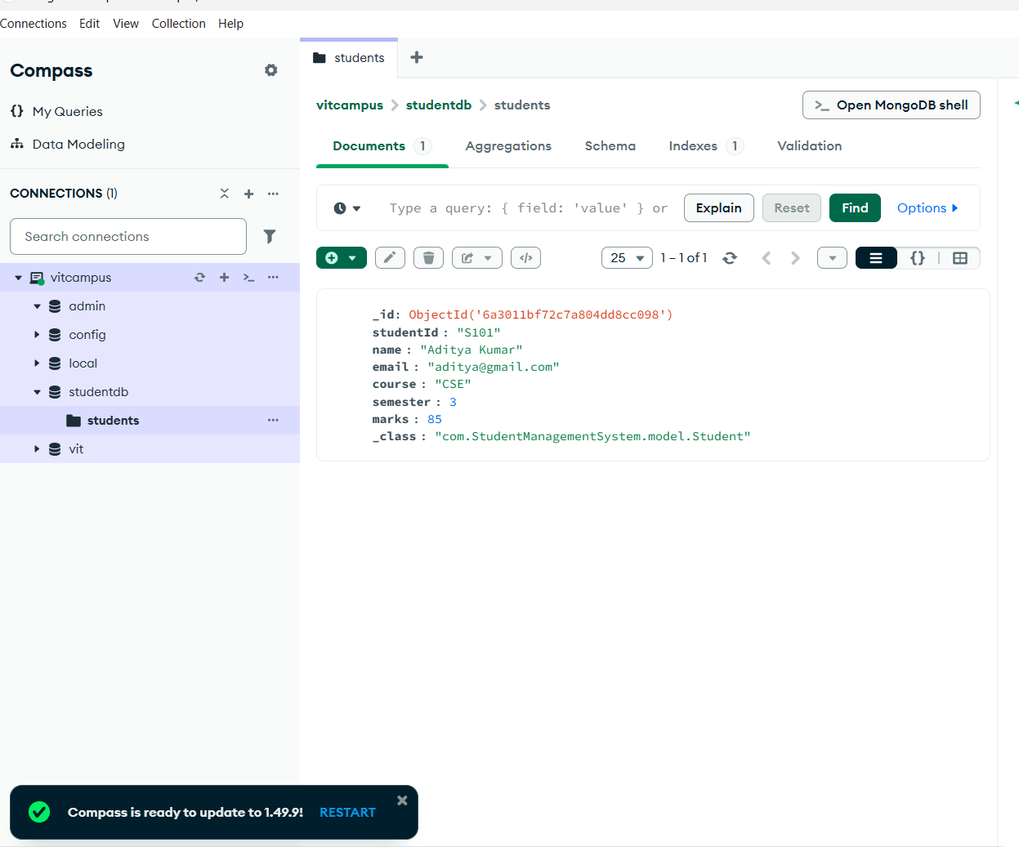

- READ ALL STUDENTS
Method: GET
URL:
http://localhost:8080/students
Result:
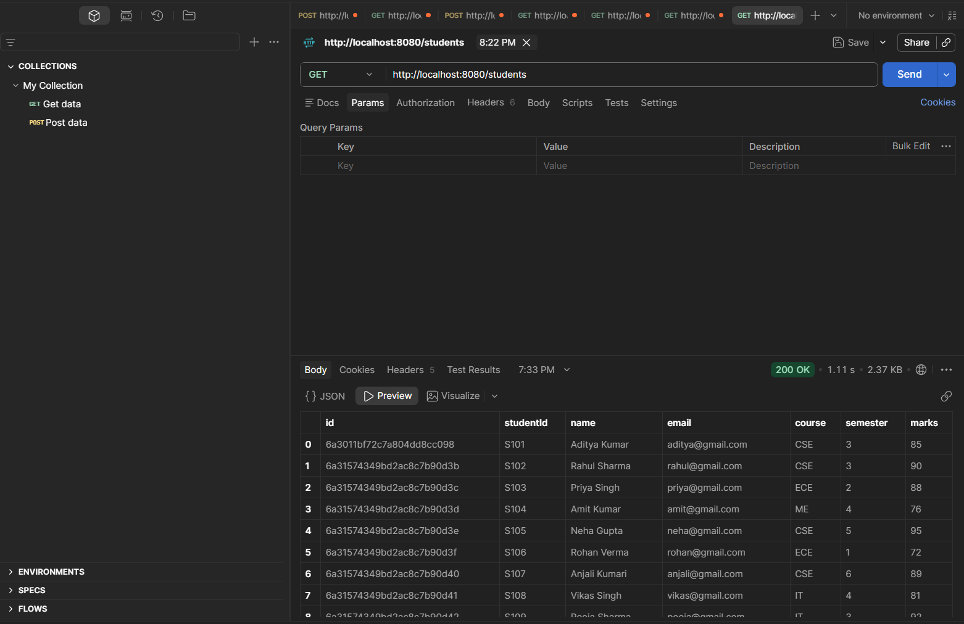

- READ STUDENT BY ID
Method: GET
URL:
http://localhost:8080/students/S105
Result:
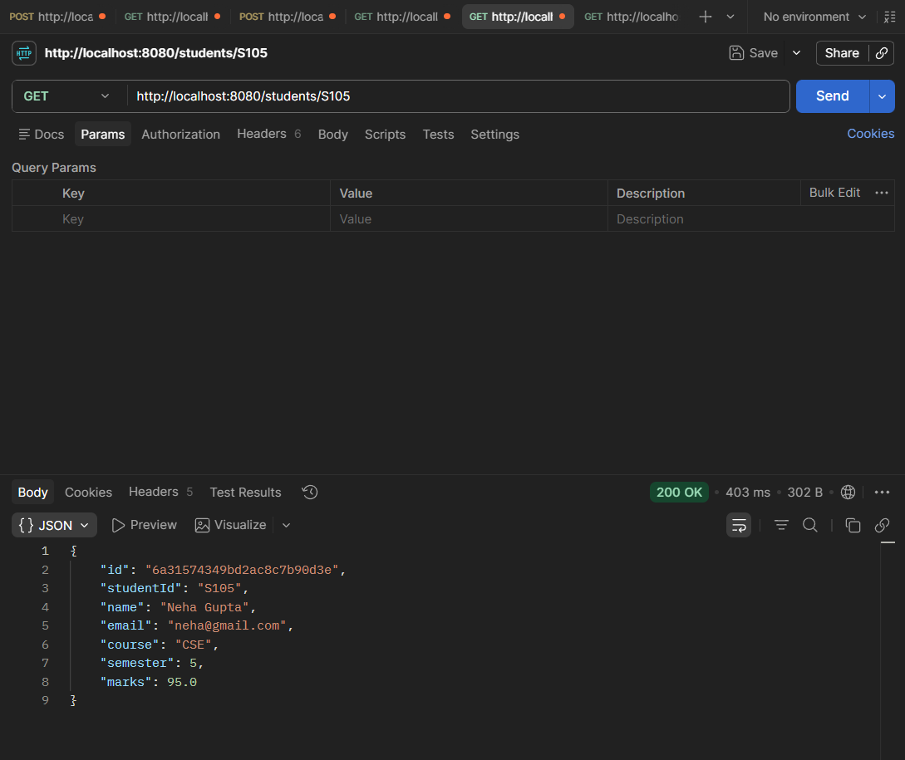.

- UPDATE STUDENT
Method: PUT
URL:
http://localhost:8080/students/S102
Result:
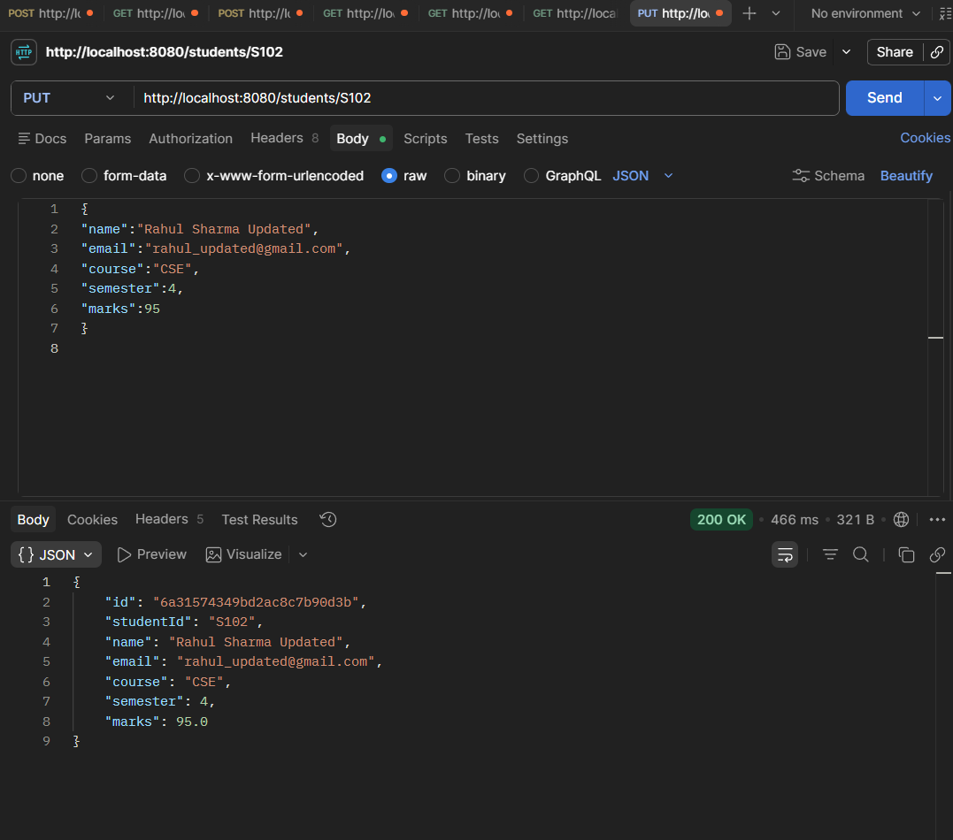

- DELETE STUDENT
Method: DELETE
URL:
http://localhost:8080/students/S117
Result:
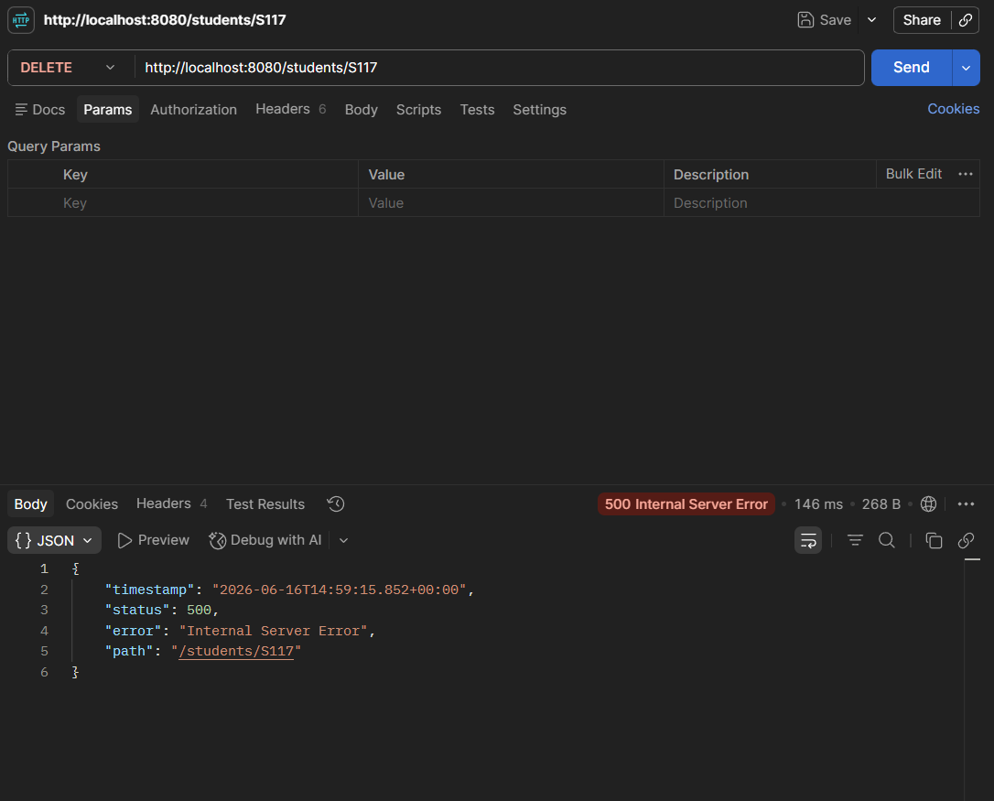

- BULK INSERT STUDENTS
Method: POST
URL:
http://localhost:8080/students/bulk
Result:
Multiple student records inserted into MongoDB at once.
